UNIVERSITY SPORTS ENGAGEMENT REPORT
UET LAHORE
Course: Applications of Information and Communication Technology Lab (AICTL)
Instructor: Ms. Ramsha Khalid
Mid-Term Project
Malik Shaher Yar Ahmad 2025-GA-27
Muhammad Sagheer 2025-GA-14
Johar Ali 2025-GA-56

- Malik Shaher Yar Ahmad (2025-GA-27)
- Muhammad Sagheer (2025-GA-14)
- Johar Ali (2025-GA-56)

Table of Contents
1. Introduction
2. Methodology
3. Gender Distribution
4. Semester Participation Summary
5. Sports Participation Overview
6. Satisfaction with Sports Facilities
7. Key Findings
8. Conclusion & Suggestions

1. Introduction
This report provides a complete and structured analysis of sports engagement among students at UET Lahore. It includes demographic summaries, participation frequency, sports interests, satisfaction levels, and areas that need improvement.

2. Methodology
Data was collected through a Google Form and includes 30 valid student responses. The form contained multiple-choice, checkbox, rating, and opinion-based questions.

3. Gender Distribution

The above chart shows the distribution of male and female respondents in the survey.
Gender | Count | Percentage
Male | 21 | 70.0%
Female | 9 | 30.0%

4. Semester Participation Summary

The chart displays the number of students who responded from each semester.

Semester / Year | Respondents
First | 16
Second | 4
Third | 4
Fifth | 4
Eighth | 1
Fourth | 1

5. Sports Participation Overview

This chart highlights the most commonly played sports among UET Lahore students.
Sport | Count
Cricket | 11
Badminton | 5
badminton | 3
Cricket 🏏 | 3
table tennis | 2
Football | 1
Fast bowling drills dail in Cricket | 1
Football.Cricket | 1
Everything | 1
Soccer | 1
Karate | 1
Cirket | 1
No | 1
None | 1
Badminton cricket or table tennis | 1
Badminton/football | 1

6. Satisfaction with Sports Facilities
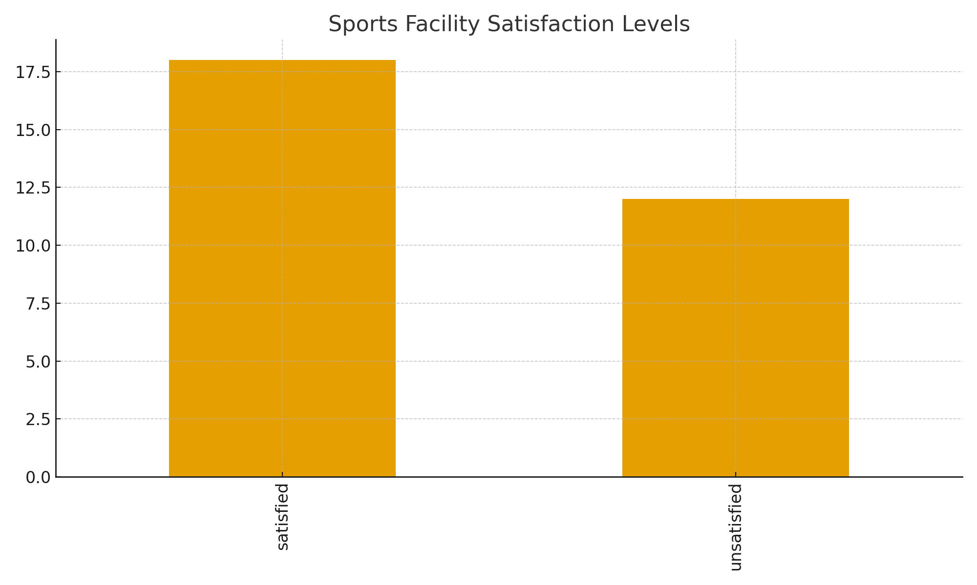
The above chart shows students’ satisfaction with the sports facilities available at UET Lahore.
Satisfaction Level | Count
satisfied | 18
unsatisfied | 12

7. Key Findings
• High participation rate in sports across multiple semesters.
• Cricket and badminton are the most popular sports.
• Mixed satisfaction levels for sports facilities.
• Students want upgraded grounds, equipment, and trained coaches.

8. Conclusion & Suggestions
Improved sports facilities and organized sports activities can greatly enhance student participation and motivation.
Suggestions:
• Expand and maintain sports grounds.
• Upgrade equipment and provide coaches.
• Organize tournaments and leagues regularly.

